STAGE 2
CASE STUDY
IFSM 310

Future IT Infrastructure

Hardware requirements

Office Printer
One office printer is required. A three in one printer is recommended for the specified Job. One that is able to Print, Scan and Photocopy Documents for efficiency with customers. Mark will be able to print invoices.

Manager’s desktop
A minimum of four (4) Desktops is required to complete the fully support the business. The required are for the:
- System Administrator: This is for the system administrator to maintain, troubleshoot and configure the network system.
- The manager: This will enable the manager to access the ERP and monitor processes in the entire business premises. This includes receiving orders from the clients
- Printing area: This is to enable the employees in the printing area to monitor schedule their job and as well editing their printing works. This may need additional desktops depending on the amount of work the business will be receiving.
- Inventory control: This is requires to enter received suppliers into the ERP and manage information on how inventory is moved to the printing area.

Mobile Phones
The mobile phone for the employee that are managing orders from clients and access the ERP remotely within the premises using Wi-Fi connectivity that will be installed. The number of units will depend with the number of employees who will be allocated the task.

FiOS Modem
This is a device that provides Internet connectivity in the premises. It links the local area network for the business to the internet through the internet service provider.

ERP Server
This will where the data for the ERP will be saved. Each employee will be able to access database for information.

Email and Database Server
Serves the entire employee in managing emails received and sent within employees and from the business clients.

3D Wireless printer
This will be able to receive command remotely from the PC computer of mobile device for printing.

Wireless Switch
This provides wireless connectivity to the premises and as well link to the servers.

Connection Cables
Cables are required for connecting all the terminals to the switch and the server to entire that each employee who cannot access the ERP system wirelessly can access through cable-connected terminal.

Software Requirements
Email & Database server software
This is installed to the email and database server that manages the enter request from all the terminals that are accessing emails and data from the server compute.
- 3D Programming Software
- Business Management software (ERP)
- Microsoft office software

Possible setup for Mark Peterson's 3D Printing business
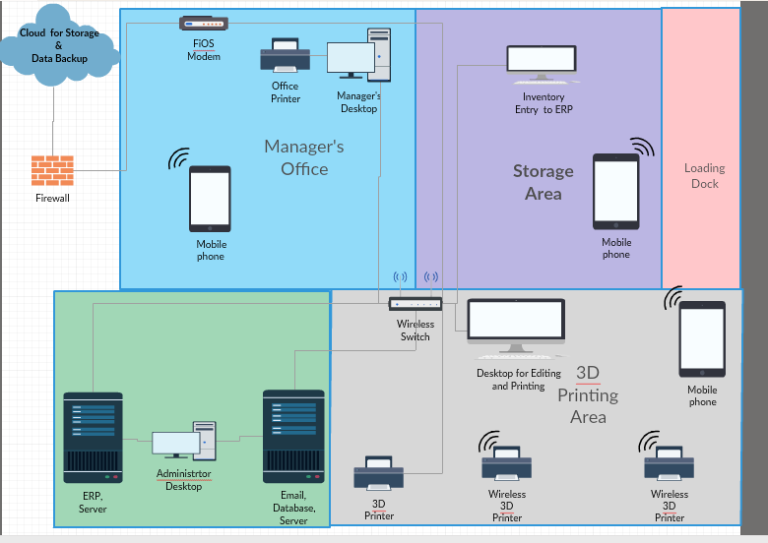
Figure 1:Hardware Plan

